1. We have already discussed what BSON is and what JSON is and what Extended JSON is.
2. MongoDB stores document in a special format called BSON.
3. It has much more data types than standard JSON.
4. 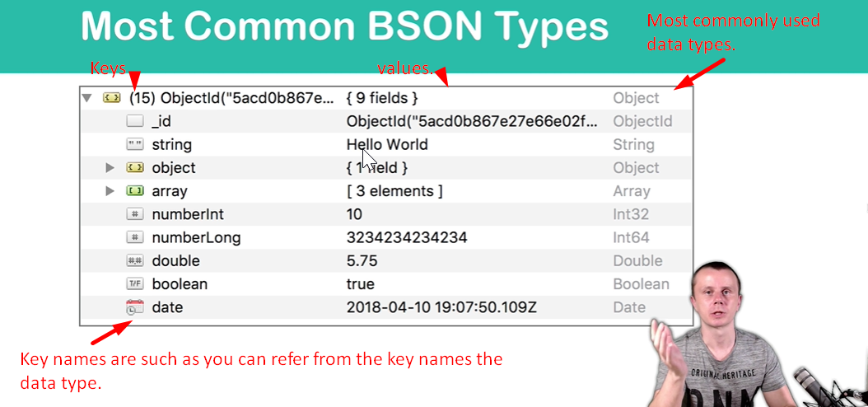
5. The above document has been taken from Robot 3T.